HW08 ECE 40400



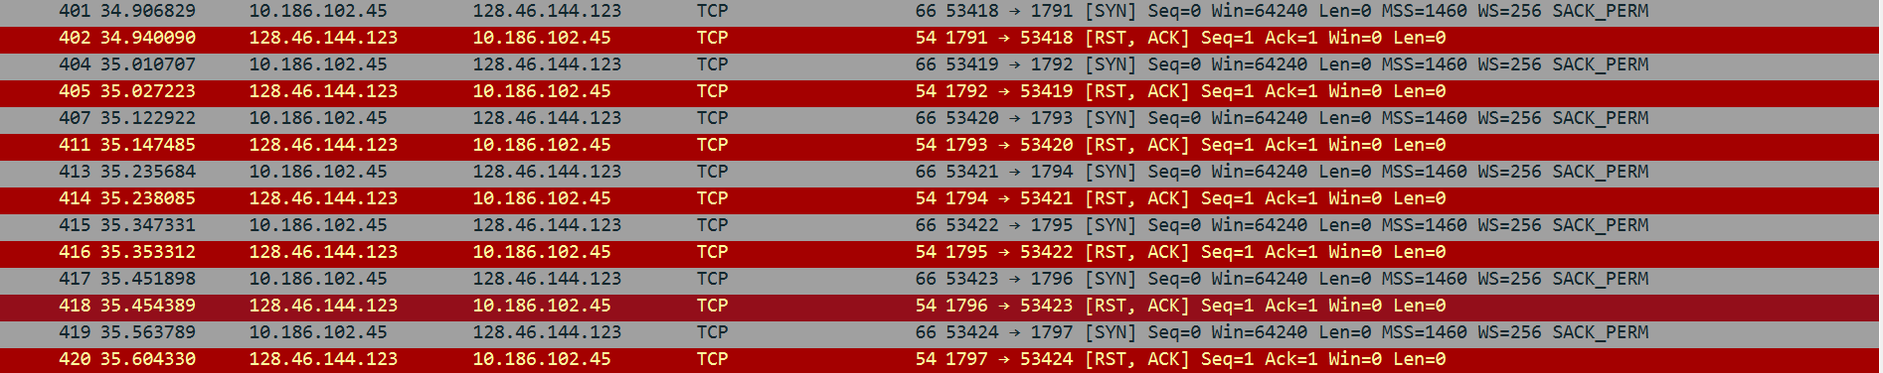



Above is a screenshot from Wireshark where we can see the ports being scanned. You can see the port numbers increasing which I’ve circled.

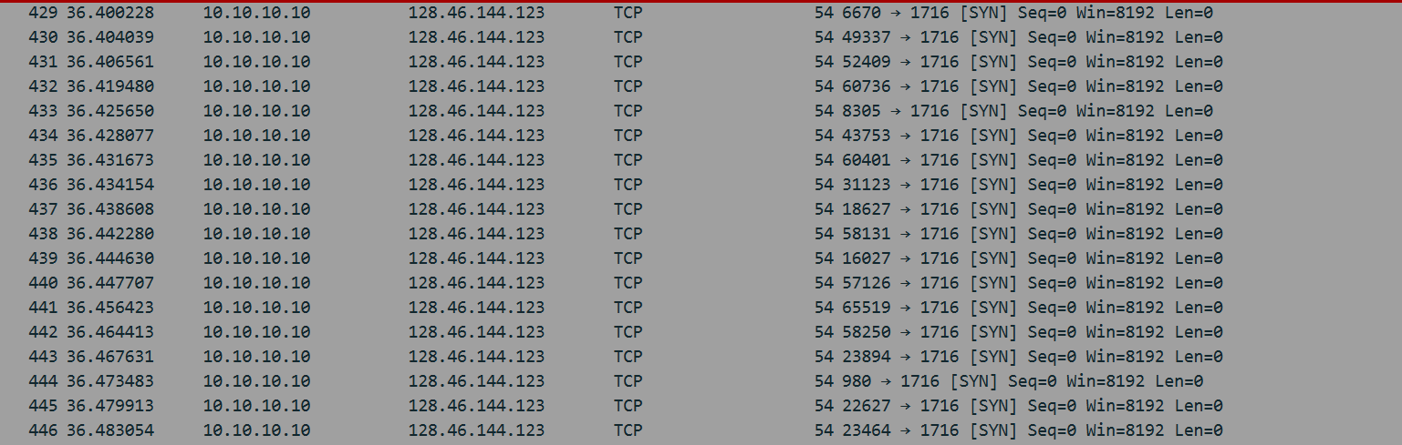

Above is a screenshot from Wireshark of the SYN Flooding attack taking place on port 1716.